
NEW HIRE ORIENTATION

INTRODUCTIONS
Welcome the new Union member. Introduce yourself and provide them with your contact information.
Explain the Sign-Up Process and give them a sign-up card to be filled out.

BASIC INFORMATION
The Name of the Union is the UGWU (United Gas Workers Union) Local 69. Our national affiliation is with the UWUA (Utility Workers Union of America)
Provide them with a copy of the By-Laws.
The structure of our Union - 5 Executive Officers / President, Vice President Majority, Vice President Minority, Secretary, and Treasurer, 6 Directors by region and 39 Stewards.
Can mention we represent two companies, Hope Gas and BHE GT&S. Provide New Hire his/her Region # and District #

CONTRACT INFORMATION
Provide the expiration date of the current contract.
Give them a copy of our Contract Book and provide a brief explanation of numerous topics included such as Grievances, Wages, Holidays, Vacations, Dependent care (hours deducted from sick time hours but not against 6 month reset date after one year of full-time service, etc.

NEW EMPLOYEE PROBABTION TIMEFRAME
Newly hired regular employees will be on probation for the first nine (9) months following employment during which time they may be terminated by the Company without recourse to the grievance procedure of the Agreement.

GRIEVANCE PROCEDURE
The Union enforces this contract by way of a Grievance Process.
The Grievance Process is explained in Section VII of this Contract. A grievance is a dispute or claim involving the meaning, interpretation, or application of any of the provisions of the Contract. Any member should contact his/her Union Steward if they feel their rights have been or are being violated. There are up to 4 steps in a grievance process as explained in detail in your contract book.

NEGOTIATED RIGHTS
Medical Benefits – You must sign up for your benefits within the first 31 days of employment. Coverage will start on your employment date. If you do not enroll within this 31-day period following your employment day, then you will not be able to enroll in a medical plan until the next annual open enrollment date, unless you experience a Qualifying Life Event (Marriage, birth of a child, etc.). Your Medical carrier is Blue Cross/ Blue Shield,

and you can choose from a Co-pay plan or high deductible plan or waive medical and receive
$75 twice per month taxable reimbursement. ((**NY members will be divided into weekly reimbursement payments))
Other benefits include Dental, Vision, Life Insurance, Long Term Disability, etc. This information was provided by the HR Dept.

401K PLAN:

- Matching contribution on gross pay and other types of special pay, such as incentive pay
- Elections of 1%-75%
- Must actively enroll.
- Company match of 100% on first 6%
- Match does not apply to traditional after-tax contribution.
- Vested after one year of service.
- Newly hired employees will have 4% of base wages deposited into their 401K in place of Cash Balance/Traditional Pension (Funds will be vested after 3 years)

JOB BIDDING

  - Eight (8) month casual bidding restriction on full time jobs (may bid within payroll location)
  - If held in a bidding restriction still able to bid on training/reserve jobs
  - You cannot rebid the job you immediately vacated.
  - New electronic bidding process online
  - Ten (10) calendar days on initial job postings
  - Five (5) calendar days on final job postings
  - Twenty-one (21) calendar days for senior bidder retest window

AIP – ANNUAL INCENTIVE PLAN
All active full-time Regular employees and part-time employees (who work at least 1,000 hours in the calendar year) as of October 31st of each year, will be eligible to share in the Company’s success under the guidelines of the plan. Specific goals are determined by the Company and reviewed with the Local 69 Executive Board. Upon the achievement of these
goals, employees will receive up to 3.75% of Qualified Earnings (the sum of base pay and OT). Payment will be included in the employees’ last check in December. Effective 2025 Key Contributor Award Program (Pilot program) based on achievement; overall business performance paid at discretion of management at .25%

RETIREE MEDICAL

HRA account funded through the VEBA (Voluntary Employee Benefit Account) by the Union. This will help offset any medical expenses after retirement. Minimum of 20 years service. (Funds TBD)

SICK TIME (SHORT TERM DISABILITY)
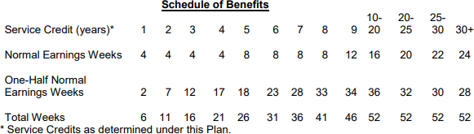

Dependent Care
Employees may use up to 40 hours of sickness/disability benefits during each calendar year to care for a sick immediate family member and/or any medical appointments. (Use of Dependent Care does not reset the employee’s sickness refresh date.) Dependent Care hours are deducted from employee’s sick hours-if you don’t have a sickness balance, you cannot use Dependent Care.
Definition of Immediate Family Member For the purposes of this policy, immediate family member is
defined as the employee’s:
- Spouse
- Child
- Parent or stepparent, or a person who stood in the place of a parent when the employee was a child under 18.
*Note: This does not include parents-in-law. **BHE will change to PTO 1/1/2027

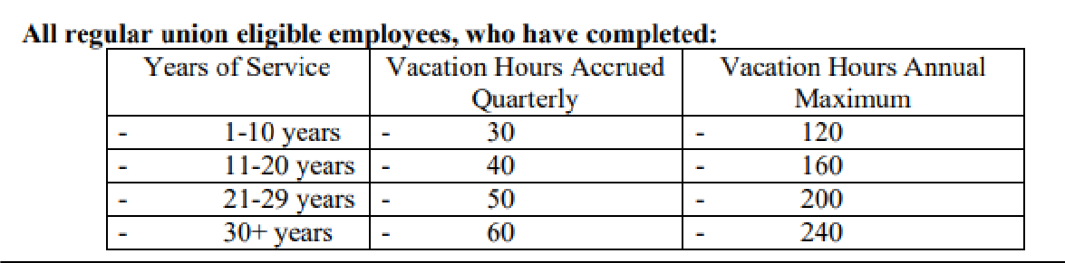
VACATION

PTO (PAID TIME OFF):
← Will be implemented on 1/1/2027
← Any unused vacation for 2025 and 2026 will be seeded into the 2027 PTO bucket
← A one-time allotment of 120 hours of sick time will also seed the 2027 PTO implementation as a separate bucket (if available) to be used for sick time, dependent care or doctor appointments
← If PTO exceeds three planned days, absences must be pre-approved
← PTO donation is available

Accrual 0-4 5.54, 5-12 7.08, 13-23 8.62, 24 or more* 10.15
PTO Hours

Annual 0-4 144, 5-12 184, 13-23 224, 24 or more* 264
PTO Hours

Maximum 0-4 216, 5-12 276, 13-23 336, 24 or more* 396 PTO Hours
Before Accrual Stops

*For employees hired on or after January 1, 2027, the PTO level of 24 or more years of service is not available

HOLIDAYS

- New Year’s Day (January 1)
- Martin Luther King Day (3rd Monday in January)
- Memorial Day (Last Monday in May)
- Independence Day (July 4)
- Labor Day (First Monday in Sept)
- Veteran’s Day (November 11)
- Thanksgiving Day (4th Thursday in November)
- Day after Thanksgiving
- Christmas Eve (December 24)
- Christmas Day (December 25)
- Floating Holiday
- Floating Holiday

*When a recognized holiday falls on a Saturday the holiday will be recognized
on the preceding Friday. When a recognized holiday falls on a Sunday it will be

recognized on the preceding Monday.
*When Christmas Day falls on a Saturday, Christmas Eve will be recognized on the preceding Thursday and Christmas Day will be recognized on the preceding Friday. When Christmas Eve falls on a Sunday, Christmas Eve will be recognized on the proceeding Monday and Christmas Day will be recognized on the proceeding Tuesday.
JOB SECURITY – As long as the company has a Contractor working somewhere within our operating area no regular employee can be laid off or offered less than 40 hours per week.
UNION MEMBERSHIP - Stewards are responsible for holding quarterly membership meetings. It is very important as a Union member to remain informed on the latest information. For the Union to be successful it takes every individual member to stand up and participate.
VOTING RIGHT - Whenever there is a reason for the Union to contact the membership about voting for the contract or for election of officers or whatever the circumstance might be you as a newly hire employee of one day’s service or of one month’s service have the ability to cast your ballot alongside a Union employee who has 30 years of service. Your service does not matter but your vote does. It is very important that you cast your vote so that your opinion will be heard.
UNION DUES - All new employees shall pay a one-time $25.00 initiation fee preferably by payroll deduction and $35.73 per pay period per member. ((**NY members is $20.37 per pay which includes the $5 strike fund amount noted below)) 10% of the Union dues shall be invested in a separate strike fund, as well as an additional flat fee of $5.00
WEINGARTEN RIGHTS – Provide new hires with a Weingarten card and give an explanation as to what these rights are.
UNION WEB PAGE - located at www.ugwulocal69.com. The contract and SPDs are online along with forms and other information that will prove very useful to them.
UNION FACEBOOK PAGE (UGWU Local 69) tells you about current events, the president’s schedule, union tour meetings, and other useful information. This page was established for the Good of the Union and to communicate to the members of Local 69. Please visit the rules section before commenting or engaging in any topic posted.

BENEFIT CONTACT NUMBERS
401K – Merrill – 800-228-4015 – benefits.ml.com
Benefits Administration Mid American 800-432-8990 Option 1– hrhelpline@midamerican.com AD&D – MetLife - 800-438-6388 - Metlife.com/mybenefits
Dental – MetLife – 800-942-0854 - Metlife.com/mybenefits
EAP – ComPsych Guidance Resources – 888-882-0796 -guidanceresources.com Employee Discount Program – BenefitHub – 866-664-4621 – bhe.benefithub.com

FML/STD/LTD – Prudential – 877-367-7781 – prudential.com/mybenefits enter 52884/control #
Flexible Spending Account – HealthEquity – 877-924-3967 – myhealthequity.com Health Savings Account – HealthEquity – 844-341-6998 – myhealthequity.com Life Insurance – MetLife – 800-438-6388 - Metlife.com/mybenefits
Medical – Wellmark Blue Cross Blue Shield – 800-287-4511 – mywellmark.com Pension – MidAmerican – 800-432-8999 Option 1-– hrhelpline@midamerican.com Prescription Drugs – Express Scripts – 855-621-9184 -express-scripts.com
Vision – VSP – 800-877-7195 – VSP.com
Voluntary Benefits – BenefitHub – 866-664-4621 - bhe.benefithub.com

PROVIDE A COPY OF SPD BOOK – Summary Plan Description of all your medical benefits.
UNION DIRECTORY – is on the Web page – The list contains the Region/District and the locations that are included in each district. They can be found at the end of the union by-laws,
UNION STEWARD – Please don’t hesitate to call me if you have any issues that arise or any
questions regarding the Contract, benefits, or any question in general.

